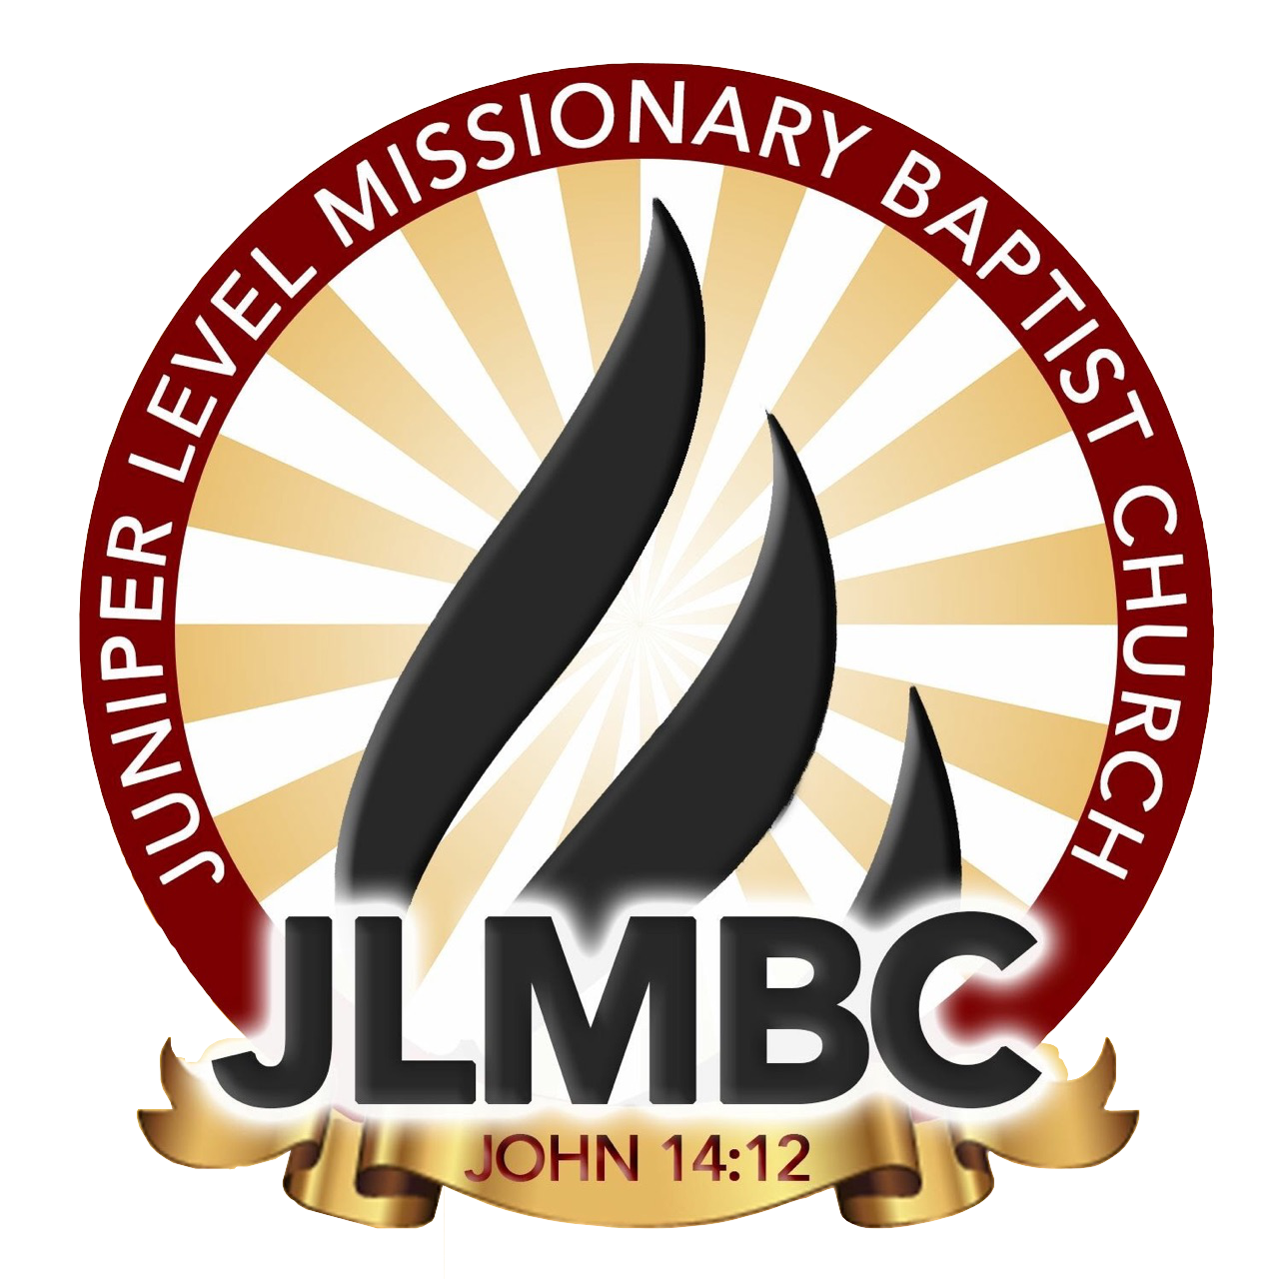
Award for Exemplary Educational Achievement

REQUIREMENTS:
Students must be a youth member of Juniper Level Missionary Baptist Church, must be active in 1 ministry. Student must have overcome obstacles in a classroom or virtually in the 2022-2023 school year and demonstrate high motivation, initiative, integrity, and intellectual depth.
ITEMS NEEDED:
Completed application
INFORMATION:
This award will be presented to a youth in elementary, middle, and high school.
LOCATION:

Rosenwald School
July 29th, 2023
4:00pm

APPLICATION DUE ON OR BEFORE ​ July 1st, 2021

Please contact LaMeesha Shavis (919)696-4191 or Kelly Wall (919)272-1256
Please send all forms to youthministry@juniperlevel.org

BASIC INFORMATION:
FULL NAME​:_________________________________________________​
SCHOOL NAME:_______________________________________GRADE:______AGE:____
MINISTRIES INVOLVED IN:___________________________________________________
______________________________________________________________________________
______________________________________________________________________________ ______________________________________________________________________________

ESSAY QUESTION:
In 150-200 words, write or type down a time you have overcome an obstacle during the 2022-2023 school year.

Once this application is signed, I understand that an incomplete application will not be accepted. I also understand that an application turned in after July 1st, 2023, will not be accepted.

Student Signature:_______________________________________________________________
Parent Signature:________________________________________________________________

