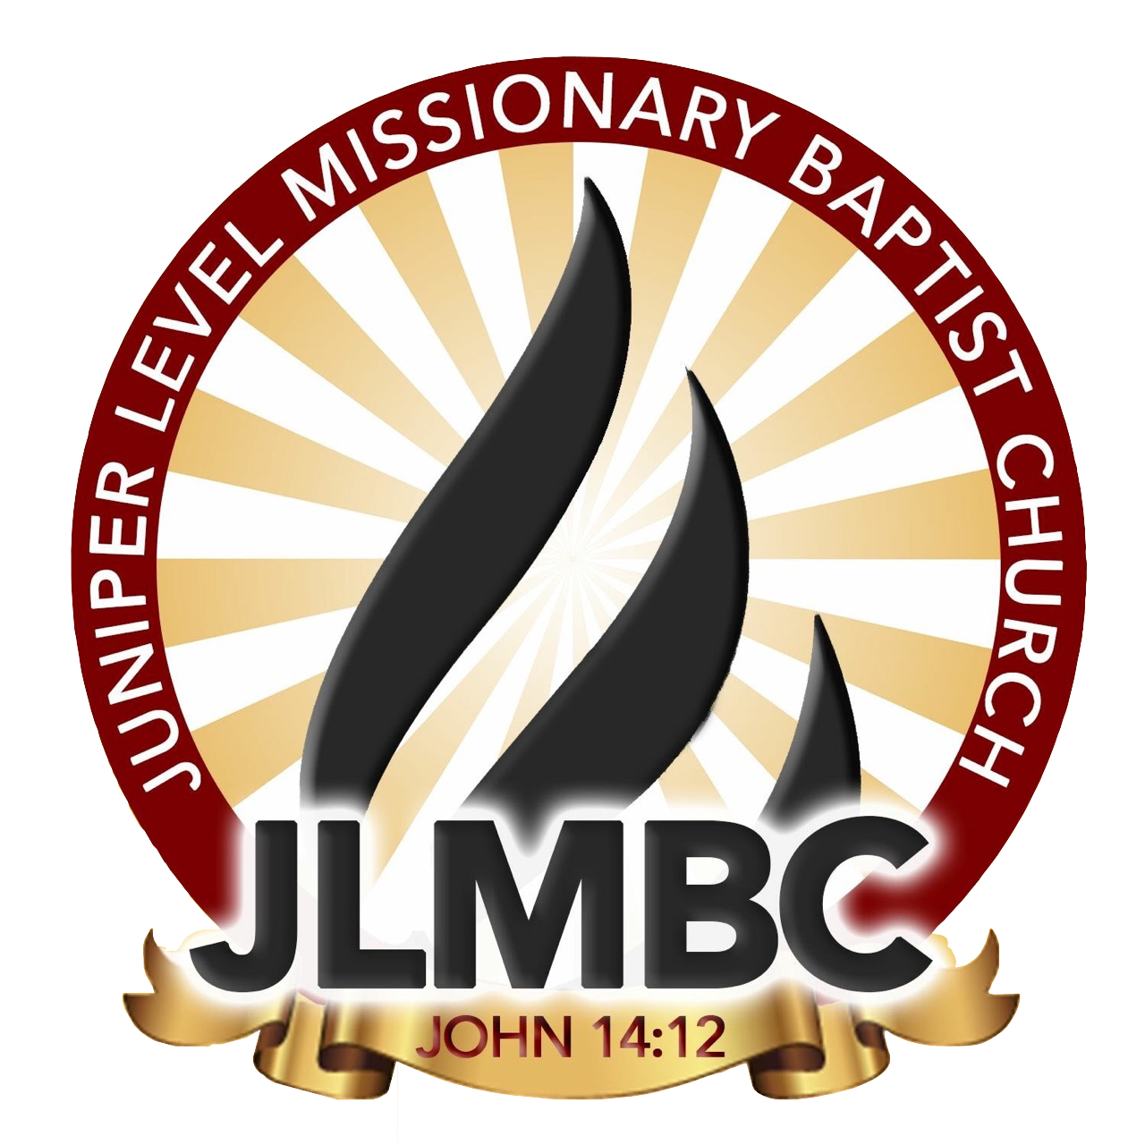

MARCUS D. WALL ATHLETIC AWARD

REQUIREMENTS:
Students must be a member of Juniper Level Missionary Baptist Church, be active in 1 ministry. Students must have been an athlete or team manager in the 2022-2023 school year, recreation, cheer, dance team or participate in a competitive sport such as karate, Judo, wrestling, etc. and demonstrate high motivation, initiative, and integrity.
ITEMS NEEDED:
Completed application, letter of recommendation from coach and sport certificate/award
INFORMATION:
This award will be presented to a youth who displays outstanding leadership on and off the court/field and athletic involvement
LOCATION:
Rosenwald School
July 29th, 2023
4:00PM

APPLICATION DUE ON OR BEFORE July 1st , 2021

Any questions or concerns
Please contact LaMeesha Shavis (919)696-4191 or Kelly Wall (919)272-1256
Please send all forms to youthministry@juniperlevel.org

BASIC INFORMATION:
FULL NAME:
SCHOOL NAME:
MINISTRY INVOLVED IN:
SPORTS INVOLVED IN:
_____________________________________________________________________________
_____________________________________________________________________________
Once this application is signed, I understand that an incomplete application will not be accepted. I also understand that an application turned in after July 1st, 2023will not be accepted.
Student Signature:
Parent Signature:

