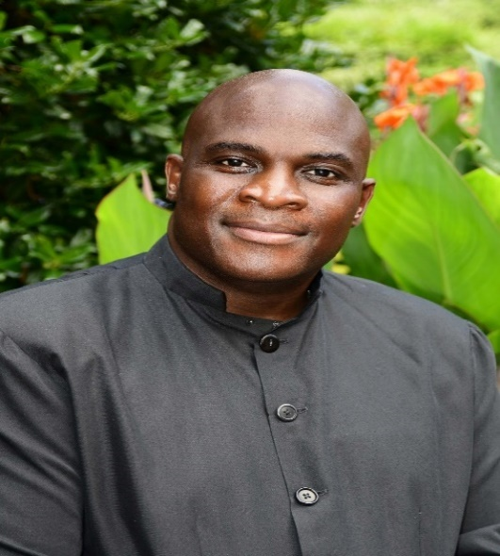
Reverend Dr. Jeffrey B. Robinson

Reverend Dr. Jeffrey B. Robinson is a pastor, teacher, and an anointed evangelist. He has been on assignment as the senior pastor at Juniper Level Missionary Baptist Church since March 2013. While under his watch, Juniper Level has experienced growth spiritually, financially, and numerically. In addition, the Rosenwald school, listed on the National Register of Historic Places, has been completely renovated and a land acquisition of 30 plus acres of land in Raleigh has been purchased for the new location of Juniper Level Missionary Baptist Church. Prior to being assigned as the senior pastor at Juniper Level, Pastor Robinson was the senior pastor for sixteen years at St. Mark Missionary Baptist Church in Oak City, North Carolina. During that time, the church experienced tremendous growth spiritually, financially, and numerically and because of the growth a new church building was needed. Seven acres of land was purchased, and in May 2001 St. Mark moved into the newly constructed church. Eight years later the church liquidated the mortgage.
Reverend Robinson has been an educator for over 27 years in the Community College System and on May 1, 2021, he retired as the Chief Campus Officer of the Public Safety Campus and Dean of Public Safety for Workforce Continuing Education at Wake Technical Community College. He has been married to the former Ms. Renee Matthews of Raleigh, North Carolina for over 28 years. First Lady Renee retired, after 28 years of service, from the North Carolina State Bureau of Investigation and the Department of Public Safety on March 1, 2017, as SBI Assistant Director/NCDPS OSI Director. She came out of retirement in August and is currently the Assistant Professor of Criminal Justice at St. Augustine’s University. The Robinsons have 3 children, Victoria, Jordan-Marie and Jeffrey and Suede, their newest family pet of the home.
Pastor Robinson believes in being actively involved in community service and he believes that serving the community makes a difference to the organization and the people being served. At home, he started an after-school care and summer program for the youth in the area. He also started a food bank and food hub for the food insecurity areas as well as a Meal on Wheels café for the Senior. Internationally, he has partnered with World Vision mission trips to Rwanda to assist with the clean water project. He has also assisted with building a Leadership center and assisted a high school and hospital with needs in Johannesburg, South Africa. He is a member of I-CARE for City of Raleigh and a member of the Board of Directors for the YMCA.
Pastor Robinson believes in being prepared for the assignment which is evident in his undergraduate, graduate and doctorate matriculation – Guilford Technical Community College, Davidson Community College, Pitt Community College (AA), North Carolina Agricultural & Technical State University (Business Management), Christian Life School of Theology, Andersonville (Theology, BA) Theological Seminary (Pastoral Counseling, MA), and Andersonville Theological Seminary (Ministry, D. Min.). He started his public service in 1985 by joining the United States Marine Corp; and, he has been a sworn law enforcement officer since 1988. He is proud to be a member of Phi Beta Sigma Fraternity INC.

