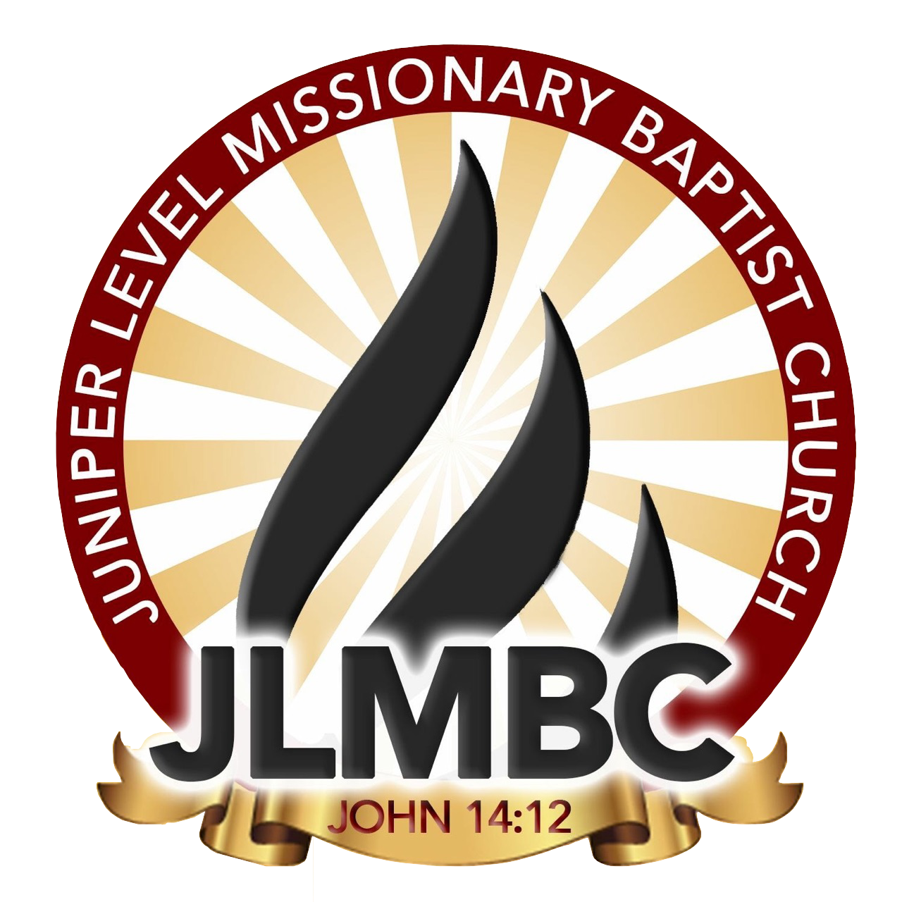
The Pastor Award
This award will be presented to a graduating senior from Juniper Level Missionary Baptist Church who exemplifies all criteria.
REQUIREMENTS:
Students must be an active JLMBC youth member, a graduate, active in 2 ministries and have volunteer hours for the past four (2) years. The student must exhibit the following characteristics: initiative, integrity, and high motivation. The student must be diligent, positive, supportive, exemplary, a role model, one who makes a difference, one who has succeeded against the odds. Student must have a GPA of 2.0
ITEMS NEEDED:
Please turn in a completed Application, transcript/report card and proof of community service. Please provide a recommendation letter from community leader (counselor, mentor, teacher, or coach) and a recommendation letter from a ministry leader (excluding Pastor, and First Lady)
Location:
The award ceremony will be held:
Rosenwald School
July
July 29th 2023
4:00pm

APPLICATION DUE ON OR BEFORE ​ July 1st, 2023 Any questions or concerns
Please contact LaMeesha Shavis (919)696-4191 or Kelly Wall (919)272-1256
Please send all forms to youthministry@juniperlevel.org

BASIC INFORMATION:
Full Name:​____________________________________________________________________
School Name​:____________________________________ Grade:_________ Age:__________ Plans after high school:_________________________________________________________ _____________________________________________________________________________
______________________________________________________________________________
______________________________________________________________________________
Ministries Involved In:__________________________________________________________
______________________________________________________________________________
______________________________________________________________________________

Community Service Opportunities:________________________________________​
__________________________________________________________________
__________________________________________________________________
__________________________________________________________________ Awards, Honors and Achievements in 2022-2023 Year:_____________ __________________________________________________________________
__________________________________________________________________
__________________________________________________________________
__________________________________________________________________
__________________________________________________________________ __________________________________________________________________

ESSAY QUESTIONS:

In 500 words, type your response to the following essay questions:
- Why do you believe that you deserve the JLMBC Pastor Awards
- What is a good Leader and how do you exemplify that?
RECOMMENDATION:
All recommendation letters from teacher, counselor, mentors, and/ or coaches can be emailed to youthministry@juniperlevel.org
Please have them provide a phone number and email address in their recommendation letter as well.

Once this application is signed, I understand that an incomplete application will not be accepted. I also understand that an application turned in after July 1st, will not be accepted.

Student Signature:_______________________________________________________________
Parent Signature:________________________________________________________________

