First Lady Renee Robinson

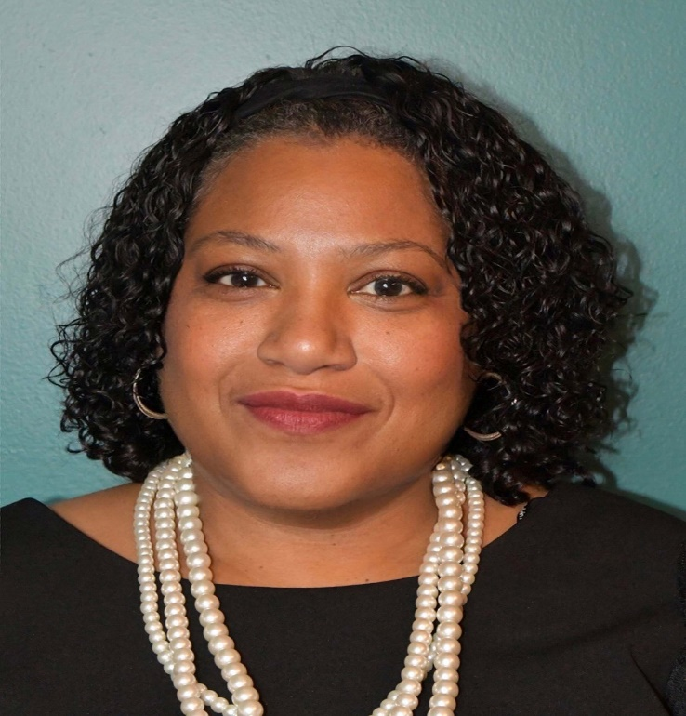
First Lady Renee Robinson is a native of Raleigh, North Carolina where she attended and graduated from Athens Drive High School. After graduation from high school, she attended the University of North Carolina at Chapel Hill graduating with a B.S. in Criminal Justice. First Lady Robinson continued her education by graduating from the National Institute of Paralegal Training in Atlanta, Georgia; North Carolina State University Administrative Office of Management Program; and East Carolina University with a M. S. in Criminal Justice.

In 1988 First Lady Robinson was hired as a Special Agent with the North Carolina State Bureau of Investigation. During her career with the NCSBI she worked a variety of investigations and received awards from DEA and BATFE. First Lady Robinson was subsequently promoted to Assistant Special Agent in Charge. In 2006 she was promoted to the Special Agent in Charge of the Northeastern District, which serves 23 counties. In 2011 she was appointed to the position of Assistant Director of the Special Operations Division of the SBI. She was the first African American female to hold that position. She also served as the Director of Special Investigations with the North Carolina Department of Public Safety. On March 2, 2017, First Lady Renee Robinson retired from the N.C. State Bureau of Investigation and the Department of Public Safety. But, in August of 2017, she came out of retirement and is currently a full time Assistant Professor of Criminal Justice at St. Augustine’s University, Raleigh.

First Lady Robinson has lived her personal and professional life serving others. She committed her life to Christ at a young age. While living in Greenville, North Carolina she became a watch care member of Cornerstone Missionary Baptist Church where she served on the usher ministry, hearing impaired ministry and Save our Sisters and Sons Ministry (SOS). She has been a choir member, taught youth Sunday School, Vacation Bible School and coordinated Youth Church. She has ministered overseas at a women’s conference in Lira, Uganda and she is very passionate about teaching and training our youth and young adults to become stronger in their Christian faith. She is not just a dedicated public servant but is also a faithful servant of the Lord Jesus Christ and is a licensed & ordained Young Adult Pastor at Juniper Level Missionary Baptist Church, Raleigh.

She has been married for over 28 years to the love of her life Reverend Dr. Jeffrey B. Robinson who is the Senior Pastor of Juniper Level Missionary Baptist Church, Raleigh. Pastor Renee is dedicated to her family. She and Dr. Robinson have three wonderful children: Victoria, Jordan-Marie and Jeffrey. First Lady Pastor Renee Robinson is excited about what God has in store for them at Juniper. Pastor Renee Robinson’s greatest joy is seeing and helping people grow stronger in their faith as they walk closer with the Lord. Her favorite scripture which she walks with daily is James 4:10 “Humble yourselves in the sight of the Lord, and he shall lift you up”.

