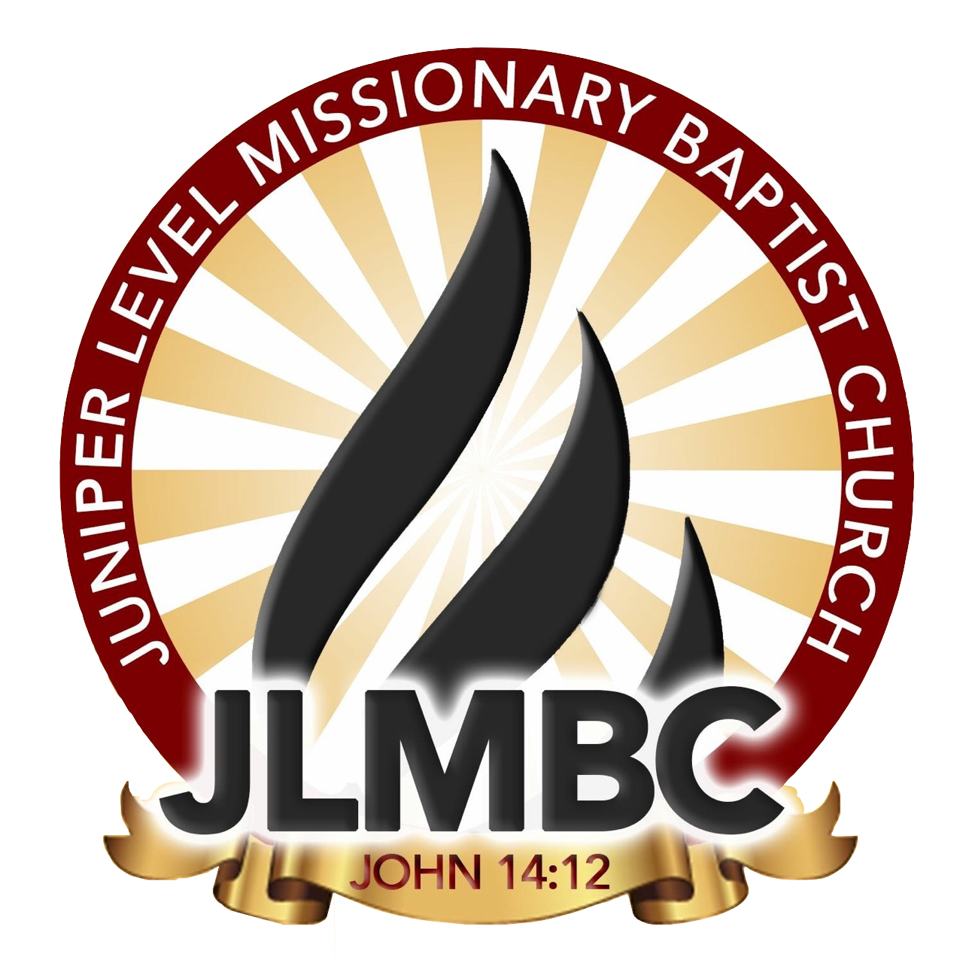

JLMBC Youth Achievement Recognition Form
(Promotion to next Grade)
2022/2023 School Year

Due on or before July 1, 2023

NAME:_______________________________________________________________________
PARENTS:_____________________________________________________________________
PHONE NUMBER:_______________________________________________________________
SCHOOL:______________________________________________________________________
GRADE:_______________________________________________________________________
GRADE PROMOTED TO:__________________________________________________________

Once this application is signed, I understand that an incomplete application will not be
accepted. I also understand that an application turned in after July 1st 2023, will not be
accepted.

Parent Signature:______________________________________________________________

Please contact LaMeesha Shavis (919)696-4191 or Kelly Wall (919)272-1256
Please send all forms to youthministry@juniperlevel.org

